Week 7 - BPSO Competition

Part A - Computing Basics (10 points)
1) What is the name of a unit that stores data in a computer?
a. CPU
b. Input
c. Memory
d. Output

2) This provides a step-by-step procedure for performing a task.
a. Keyboard
b. Algorithm
c. Internet
d. Windows

3) Which one of the following is NOT a programming language?
a. Java
b. Python
c. C++
d. Binary

4) Which of the following is NOT a computer peripheral?
a. Keyboard
b. CPU
c. Mouse
d. Printer

5) What is the name for an error in a computer program that makes it function incorrectly?
a. Variable
b. Sprite
C. Bug
D. Mouse

Part B - Computing “Theory”

1. Convert 99 from decimal to binary.

a. Show your steps for conversion. (3 pts.)
b. Write the final answer and circle it. (2 pts.)

2. The following is the algorithm for a certain task.

i. ‘numbers’ is a list of positive numbers
ii. ‘m’ is a number, initially set to 0
iii. for each number in the list, if the number is greater than ‘m’, set m to be equal to the number
iv. after checking all the numbers in the list, print ‘m’

a. Explain in a sentence or two what this algorithm is doing. What is the final result it is computing? (3 pts.)
b. Show how the algorithm would run if ‘numbers’ = [13, 5, 22, 7] Show each step and circle the final answer that would print. (2 pts.)

3. You are given a bag full of coins - pennies, nickels, dimes, and quarters. You have to sort them into four boxes, each holding one type of coin only. So, the first box should have all pennies, the second all nickels, and so on. Draw a flowchart for this activity. Keep in mind you can take only one coin at a time and place it in the appropriate box before you pick another one. Make sure to use the correct flowchart symbols and all “decision” steps can only have a “yes” and “no” arrow coming out of them. (5 pts)

Part C - Practical Computing

Scoring:
30 points total, based on the following breakdown:
o 10 points for a correct algorithm that uses proper programming constructs
o 10 points for a working program
o 5 points for attention to precision
o 5 points for creativity and/or efficiency (tie-breaker)

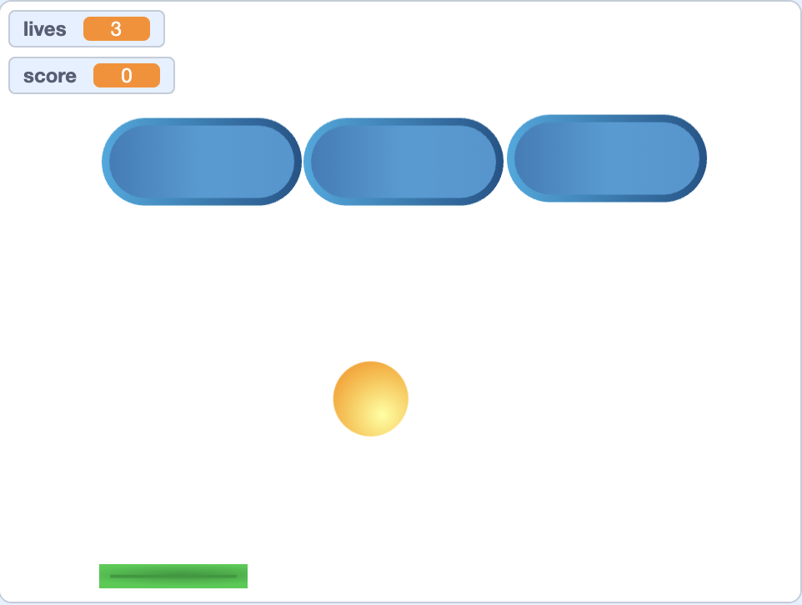

Create a Breakout Game that meets the following specifications:
- The ball starts in the middle of the screen and heads downward at a random (downward) angle
- The player can move the paddle left and right with the arrow keys. The paddle cannot move up or down.
- When the ball hits the paddle it bounces back the way a real ball would (think about this–at what angle should it come off the paddle?)
- When the ball hits the sides or top, it bounces like (also like a real ball would)
- When the ball hits a block, the block disappears and the score goes up.
- When all 3 blocks have been cleared, they all reappear after a short delay.
- When the ball hits the bottom of the screen the player loses a life.
- When the ball hits the bottom of the screen it restarts in the middle of the screen and starts downwards, as in point #1.
- The game starts with 3 lives and a score of 0.
- The game is over when the player loses all lives.

